**Ex. No: 1**

**Date:**

**Greatest of Three Numbers Using GUI Components**

**Aim:** To Develop an application that finds greatest among three numbers using GUI Components

# Algorithm:

**Step 1:** Start Android Visual Studio

**Step 2:** Create a project using project wizard.

**Step 3:** Test all resource are working smoothly.

**Step 4:** Click on Project Explorer Toolbar navigate to Project->app->src->main->res-

>layout->activity_main.xml.

**Step 5:** Design your page with three textbox, labels and button align them properly.

**Step 6:** Go to Project->app->src->main->java->MainActivity.java

**Step 7:** Add variable for getting input and map them to suitable textboxes. **Step 8:** Create event for the button OnClickListener() to perform operation **Step 9:** Compute the result and display.

**Step 10:** Run the program using Android Emulator with proper Settings.

### Source Code:

**Mainactivity.java**

**Package** com.example.largestnum;

**import** androidx.appcompat.app.AppCompatActivity;

**import** android.os.Bundle; **import** android.view.View; **import** android.widget.Button; **import** android.widget.EditText; **import** android.widget.TextView;

**public class** MainActivity **extends** AppCompatActivity {

**public** EditText **mEditT1**; **public** EditText **mEditT2**; **public** EditText **mEditT3**; **public** TextView **mResultT4**;

@Override

**protected void** onCreate(Bundle savedInstanceState) { **super**.onCreate(savedInstanceState); setContentView(R.layout.***activity_main***);

**mEditT1** = findViewById(R.id.***editTextNumber1***); **mEditT2**= findViewById(R.id.***editTextNumber2***); **mEditT3**= findViewById(R.id.***editTextNumber3***); **mResultT4** = findViewById(R.id.***resultView***); Button mButtonFind = findViewById(R.id.***button***);

mButtonFind.setOnClickListener(**new** View.OnClickListener() { @Override

**public void** onClick(View view) {

**if** (**mEditT1**.getText().toString().length() == 0) {

**mEditT1**.setText(**"0"**);

}

**if** (**mEditT2**.getText().toString().length() == 0) {

**mEditT2**.setText(**"0"**);

}

**if** (**mEditT3**.getText().toString().length() == 0) {

**mEditT3**.setText(**"0"**);

}

**int** num1 = Integer.*parseInt*(**mEditT1**.getText().toString()); **int** num2 = Integer.*parseInt*(**mEditT2**.getText().toString()); **int** num3 = Integer.*parseInt*(**mEditT1**.getText().toString()); **int** result=((num1>num2)?(Math.*max*(num1,

num3)):(Math.*max*(num2, num3)));

**mResultT4**.setText(String.*valueOf*(result));

}

});

}

}

### Activity_main.xml:

*<?*xml version="1.0" encoding="utf-8"*?>*

<androidx.constraintlayout.widget.ConstraintLayout xmlns:android[="http://schemas.android.com/apk/res/android"](http://schemas.android.com/apk/res/android)

xmlns:app[="http://schemas.android.com/apk/res](http://schemas.android.com/apk/res-auto)-[auto"](http://schemas.android.com/apk/res-auto) xmlns:tools[="http://schemas.android.com/tools"](http://schemas.android.com/tools) android:layout_width="match_parent" android:layout_height="match_parent" tools:context=".MainActivity">

<TextView

android:id="@+id/textView3" android:layout_width="102dp" android:layout_height="54dp" android:layout_marginEnd="72dp" android:layout_marginBottom="320dp" android:background="#FFEB3B" android:text="@string/number_3"

android:textAppearance="@style/TextAppearance.AppCompat.Medium" app:layout_constraintBottom_toBottomOf="parent" app:layout_constraintEnd_toStartOf="@+id/editTextNumber3" tools:ignore="MissingConstraints" />

<EditText

android:id="@+id/editTextNumber1" android:layout_width="153dp" android:layout_height="48dp" android:layout_marginEnd="16dp" android:layout_marginBottom="484dp" android:autofillHints="" android:ems="10" android:inputType="number"

app:layout_constraintBottom_toBottomOf="parent" app:layout_constraintEnd_toEndOf="parent" tools:ignore="LabelFor,SpeakableTextPresentCheck" />

<EditText

android:id="@+id/editTextNumber2" android:layout_width="157dp" android:layout_height="48dp" android:layout_marginEnd="16dp" android:layout_marginBottom="404dp" android:autofillHints="" android:ems="10" android:inputType="number"

app:layout_constraintBottom_toBottomOf="parent" app:layout_constraintEnd_toEndOf="parent" tools:ignore="LabelFor,SpeakableTextPresentCheck" />

<androidx.constraintlayout.widget.Guideline android:id="@+id/guideline2" android:layout_width="wrap_content" android:layout_height="wrap_content" android:orientation="vertical" app:layout_constraintGuide_begin="-37dp" />

<EditText

android:id="@+id/editTextNumber3" android:layout_width="160dp" android:layout_height="50dp"

android:layout_marginEnd="16dp" android:layout_marginBottom="320dp" android:autofillHints="" android:ems="10" android:inputType="number"

app:layout_constraintBottom_toBottomOf="parent" app:layout_constraintEnd_toEndOf="parent" tools:ignore="LabelFor,SpeakableTextPresentCheck" />

<Button

android:id="@+id/button" android:layout_width="wrap_content" android:layout_height="wrap_content" android:layout_marginBottom="180dp" android:text="@string/find" app:layout_constraintBottom_toBottomOf="parent" app:layout_constraintEnd_toEndOf="parent" app:layout_constraintHorizontal_bias="0.498" app:layout_constraintStart_toStartOf="parent" />

<TextView

android:id="@+id/resultView" android:layout_width="116dp" android:layout_height="75dp" android:layout_marginBottom="72dp" app:layout_constraintBottom_toBottomOf="parent" app:layout_constraintEnd_toEndOf="parent" app:layout_constraintHorizontal_bias="0.5" app:layout_constraintStart_toStartOf="parent" />

<TextView

android:id="@+id/textView" android:layout_width="102dp" android:layout_height="52dp" android:layout_marginEnd="80dp" android:layout_marginBottom="484dp" android:background="#FFEB3B" android:text="@string/number_1"

android:textAppearance="@style/TextAppearance.AppCompat.Medium" app:layout_constraintBottom_toBottomOf="parent" app:layout_constraintEnd_toStartOf="@+id/editTextNumber1" tools:ignore="MissingConstraints" />

<TextView

android:id="@+id/textView2" android:layout_width="102dp" android:layout_height="53dp" android:layout_marginEnd="76dp" android:layout_marginBottom="404dp" android:background="#FFEB3B" android:backgroundTint="#FFEB3B" android:text="@string/number_2"

android:textAppearance="@style/TextAppearance.AppCompat.Medium" app:layout_constraintBottom_toBottomOf="parent" app:layout_constraintEnd_toStartOf="@+id/editTextNumber2" tools:ignore="MissingConstraints" />

</androidx.constraintlayout.widget.ConstraintLayout>

### Design Screenshots:

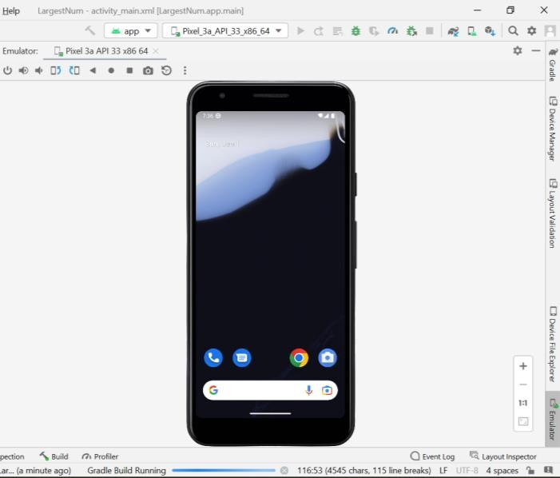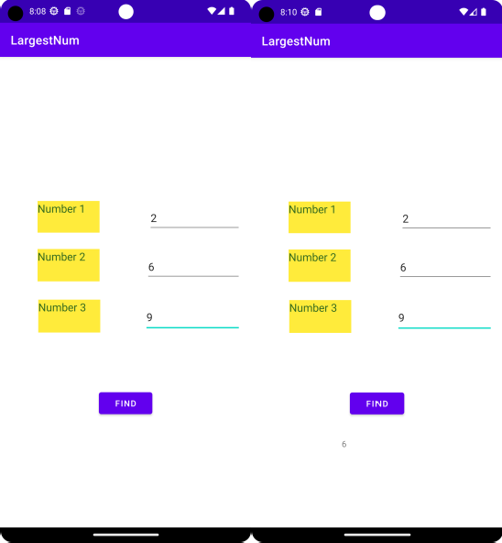

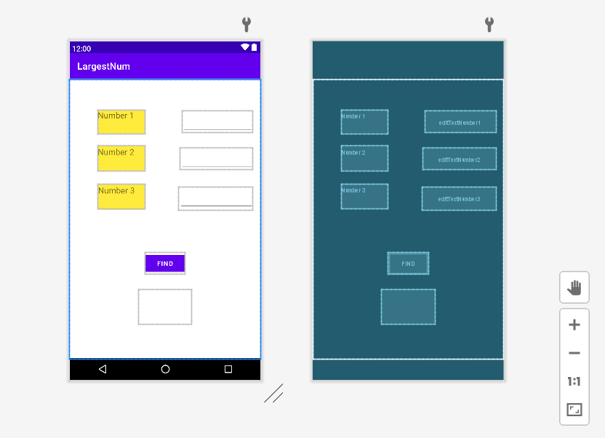

**Output Screenshots:**

**Ex. No: 2**

**Date:**

**Personal details using GUI Components**

# Aim:

To Develop an application to display your personal details using GUI Components.

**Algorithm:**

**Source Code:**

## Main Activity.xml

*<?*xml version="1.0" encoding="utf-8"*?>*

<LinearLayout xmlns:android[="http://schemas.android.com/apk/res/android"](http://schemas.android.com/apk/res/android) xmlns:tools[="http://schemas.android.com/tools"](http://schemas.android.com/tools) android:layout_width="match_parent" android:layout_height="match_parent"

android:orientation="vertical" android:layout_gravity="center" android:background="@drawable/bground" tools:context=".MainActivity">

<LinearLayout

android:orientation="vertical" android:layout_width="match_parent" android:layout_height="wrap_content">

<LinearLayout

android:padding="8dp" android:orientation="horizontal" android:layout_width="match_parent" android:layout_height="?attr/actionBarSize">

<RelativeLayout android:layout_width="match_parent" android:layout_height="match_parent" tools:ignore="UselessParent">

<ImageView

android:padding="5dp" android:layout_alignParentStart="true" android:src="@drawable/ic_arrowl_foreground" android:layout_width="40dp" android:layout_height="40dp" tools:ignore="ContentDescription" />

</RelativeLayout>

</LinearLayout>

<LinearLayout

android:orientation="vertical" android:layout_width="match_parent" android:layout_height="wrap_content">

<TextView

android:layout_width="match_parent" android:layout_height="wrap_content"

android:layout_marginStart="15dp" android:text="@string/my" android:textColor="#00695C" android:textSize="30sp" android:textStyle="normal"

tools:ignore="TextContrastCheck,TextContrastCheck" />

<TextView

android:layout_width="match_parent" android:layout_height="wrap_content" android:layout_marginStart="15dp" android:text="@string/profile" android:textColor="#0097A7" android:textSize="33sp" android:textStyle="bold" tools:ignore="TextContrastCheck" />

</LinearLayout>

</LinearLayout>

<include

android:layout_gravity="center" layout="@layout/item_image" android:layout_height="wrap_content" android:layout_marginLeft="16dp" android:layout_marginRight="16dp" android:layout_width="match_parent" />

<ScrollView

android:layout_width="match_parent" android:layout_height="wrap_content">

<LinearLayout

android:orientation="vertical" android:layout_width="match_parent" android:layout_height="wrap_content">

<include layout="@layout/item_add"/>

<include layout="@layout/item_info"/>

<include layout="@layout/item_email"/>

</LinearLayout>

</**ScrollView**>

</LinearLayout>

Add.xml

*<?*xml version="1.0" encoding="utf-8"*?>*

<androidx.cardview.widget.CardView xmlns:android[="http://schemas.android.com/apk/res/android"](http://schemas.android.com/apk/res/android) android:layout_width="match_parent" android:layout_height="wrap_content" xmlns:app[="http://schemas.android.com/apk/res](http://schemas.android.com/apk/res-auto)-[auto"](http://schemas.android.com/apk/res-auto) xmlns:card_view[="http://schemas.android.com/tools"](http://schemas.android.com/tools) app:cardCornerRadius="15dp"

app:cardElevation="10dp" app:cardUseCompatPadding="true" card_view:cardCornerRAdius="5dp">

<LinearLayout

android:orientation="vertical" android:padding="8dp" android:layout_width="match_parent" android:layout_height="wrap_content">

<RelativeLayout android:layout_width="match_parent" android:layout_height="wrap_content">

<LinearLayout

android:orientation="horizontal" android:padding="1dp" android:gravity="center" android:layout_alignParentStart="true" android:layout_width="wrap_content" android:layout_height="wrap_content"

card_view:ignore="RelativeOverlap,UseCompoundDrawables">

<ImageView

android:padding="1dp" android:src="@drawable/ic_person1_foreground" android:layout_width="35dp" android:layout_height="35dp" card_view:ignore="ContentDescription" />

<TextView

android:text="@string/address" android:textSize="16sp" android:layout_margin="5dp" android:textStyle="bold|normal" android:textColor="#0E0E0E" android:layout_width="wrap_content" android:layout_height="wrap_content"/>

</LinearLayout>

<LinearLayout

android:orientation="horizontal" android:padding="1dp" android:gravity="center" android:layout_alignParentEnd="true" android:layout_width="wrap_content" android:layout_height="wrap_content"

card_view:ignore="RelativeOverlap,UseCompoundDrawables">

<ImageView

android:padding="1dp" android:src="@drawable/ic_add_foreground" android:layout_width="35dp" android:layout_height="35dp" card_view:ignore="ContentDescription" />

<TextView

android:text="@string/add_information"

android:textSize="16sp" android:layout_margin="5dp" android:textStyle="bold|normal" android:textColor="#0E0E0E" android:layout_width="wrap_content" android:layout_height="wrap_content"/>

</LinearLayout>

</RelativeLayout>

<LinearLayout

android:orientation="horizontal" android:layout_width="match_parent" android:layout_height="wrap_content">

<ImageView

app:tint="@color/black" android:padding="2dp" android:layout_marginStart="10dp" android:src="@drawable/ic_home" android:layout_width="25dp" android:layout_height="25dp" card_view:ignore="ContentDescription" />

<LinearLayout

android:orientation="vertical" android:layout_width="match_parent" android:layout_height="wrap_content">

<TextView

android:text="@string/no_88_main_road" android:textSize="17sp" android:textColor="@color/black" android:textStyle="bold" android:gravity="center" android:layout_width="wrap_content" android:layout_height="wrap_content"/>

<TextView

android:text="@string/zamin_pallavaram_chennai_43" android:textSize="15sp" android:textColor="@color/black" android:textStyle="bold" android:textAlignment="textStart" android:layout_width="wrap_content" android:layout_height="wrap_content" card_view:ignore="RtlCompat"/>

</LinearLayout>

</LinearLayout>

</LinearLayout>

</androidx.cardview.widget.CardView>

### Email.xml

*<?*xml version="1.0" encoding="utf-8"*?>*

<androidx.cardview.widget.CardView xmlns:android[="http://schemas.android.com/apk/res/android"](http://schemas.android.com/apk/res/android) android:layout_width="match_parent" android:layout_height="wrap_content" xmlns:app[="http://schemas.android.com/apk/res](http://schemas.android.com/apk/res-auto)-[auto"](http://schemas.android.com/apk/res-auto) xmlns:card_view[="http://schemas.android.com/tools"](http://schemas.android.com/tools) app:cardCornerRadius="15dp"

app:cardElevation="10dp" app:cardUseCompatPadding="true" card_view:cardCornerRAdius="5dp">

<LinearLayout

android:orientation="vertical" android:layout_width="match_parent" android:layout_height="wrap_content">

<LinearLayout

android:orientation="horizontal" android:padding="3dp" android:layout_width="match_parent" android:layout_height="wrap_content" card_view:ignore="UseCompoundDrawables">

<ImageView

android:padding="2dp" android:src="@drawable/ic_email_foreground" android:layout_marginStart="5dp" android:layout_width="30dp" android:layout_height="30dp" card_view:ignore="ContentDescription" />

<TextView

android:text="@string/email" android:layout_marginStart="10dp" android:textSize="14sp" android:textStyle="bold" android:layout_gravity="center" android:textColor="#605E5E" android:layout_width="wrap_content" android:layout_height="wrap_content"/>

</LinearLayout>

<TextView android:text[="dineshlogo02@gmail.com"](mailto:dineshlogo02@gmail.com) android:textStyle="bold" android:textColor="@color/black" android:textSize="18sp" android:layout_marginStart="25dp" android:layout_marginBottom="15dp" android:layout_width="wrap_content" android:layout_height="wrap_content" card_view:ignore="HardcodedText" />

</LinearLayout>

</androidx.cardview.widget.CardView>

### Info.xml

*<?*xml version="1.0" encoding="utf-8"*?>*

<androidx.cardview.widget.CardView xmlns:android[="http://schemas.android.com/apk/res/android"](http://schemas.android.com/apk/res/android) android:layout_width="match_parent" android:layout_height="wrap_content" xmlns:app[="http://schemas.android.com/apk/res](http://schemas.android.com/apk/res-auto)-[auto"](http://schemas.android.com/apk/res-auto) xmlns:card_view[="http://schemas.android.com/tools"](http://schemas.android.com/tools) app:cardCornerRadius="15dp"

app:cardElevation="10dp" app:cardUseCompatPadding="true" card_view:cardCornerRAdius="5dp">

<LinearLayout

android:orientation="vertical" android:layout_width="match_parent" android:layout_height="wrap_content">

<LinearLayout

android:orientation="horizontal" android:padding="3dp" android:layout_width="match_parent" android:layout_height="wrap_content" card_view:ignore="UseCompoundDrawables">

<ImageView

android:padding="2dp" android:src="@drawable/ic_phonering_foreground" android:layout_marginStart="5dp" android:layout_width="30dp" android:layout_height="30dp" card_view:ignore="ContentDescription" />

<TextView

android:text="@string/mobile" android:layout_marginStart="10dp" android:textSize="14sp" android:textStyle="bold" android:layout_gravity="center" android:textColor="#605E5E" android:layout_width="wrap_content" android:layout_height="wrap_content"/>

</LinearLayout>

<TextView

android:text="+91 9551898456" android:textStyle="bold" android:textColor="@color/black" android:textSize="18sp" android:layout_marginStart="25dp" android:layout_marginBottom="15dp" android:layout_width="wrap_content" android:layout_height="wrap_content" card_view:ignore="HardcodedText" />

</LinearLayout>

</androidx.cardview.widget.CardView>

### Image.xml

*?*xml version="1.0" encoding="utf-8"*?>*

<RelativeLayout xmlns:android[="http://schemas.android.com/apk/res/android"](http://schemas.android.com/apk/res/android) android:layout_width="match_parent" android:layout_height="wrap_content" xmlns:app[="http://schemas.android.com/apk/res](http://schemas.android.com/apk/res-auto)-[auto"](http://schemas.android.com/apk/res-auto) xmlns:card_view[="http://schemas.android.com/tools"](http://schemas.android.com/tools) android:layout_centerInParent="true"

android:gravity="center">

<RelativeLayout android:layout_centerInParent="true" android:layout_width="match_parent" android:layout_height="250dp">

<androidx.cardview.widget.CardView app:cardCornerRadius="15dp" android:layout_marginTop="40dp" app:cardElevation="10dp" app:cardUseCompatPadding="true" card_view:cardCornerRAdius="5dp" android:layout_width="match_parent" android:layout_height="240dp">

<LinearLayout

android:orientation="vertical" android:layout_marginTop="23dp" android:layout_width="match_parent" android:layout_height="match_parent">

<TextView

android:layout_marginTop="15dp" android:text="Dinesh" android:textSize="20sp" android:textStyle="bold" android:gravity="center" android:textColor="@color/black" android:layout_width="match_parent" android:layout_height="wrap_content" card_view:ignore="HardcodedText" />

<TextView

android:layout_marginTop="2dp" android:text="@string/pid_27414" android:textSize="13sp" android:textStyle="normal" android:layout_marginBottom="10dp" android:gravity="center" android:textColor="#5C5A5A" android:layout_width="match_parent" android:layout_height="wrap_content"/>

<View

android:background="#79D6D1D1" android:layout_width="match_parent" android:layout_height="1dp"/>

<LinearLayout

android:orientation="horizontal" android:weightSum="3" android:gravity="center" android:layout_width="match_parent" android:layout_height="match_parent">

<TextView

android:layout_weight="1" android:text="@string/personal_info" android:gravity="center"

android:textStyle="bold" android:textSize="14sp" android:textColor="@color/black" android:layout_width="0dp" android:layout_height="wrap_content"/>

<View

android:background="#79D6D1D1" android:layout_width="1dp" android:layout_height="match_parent"/>

<TextView

android:layout_weight="1" android:text="@string/family" android:gravity="center" android:textStyle="bold" android:textSize="14sp" android:textColor="#636262" android:layout_width="0dp" android:layout_height="wrap_content"/>

<View

android:background="#79D6D1D1" android:layout_width="1dp" android:layout_height="match_parent"/>

<TextView

android:layout_weight="1" android:text="@string/vitals" android:gravity="center" android:textStyle="bold" android:textSize="14sp" android:textColor="#636262" android:layout_width="0dp" android:layout_height="wrap_content"/>

</LinearLayout>

</LinearLayout>

</androidx.cardview.widget.CardView>

</RelativeLayout>

<com.google.android.material.imageview.ShapeableImageView android:src="@drawable/dp" app:shapeAppearanceOverlay="@style/Circular" android:elevation="15dp"

android:padding="5dp" android:layout_centerHorizontal="true" android:layout_width="98dp" android:layout_height="98dp"/>

</RelativeLayout>

### Design Screen Shot:

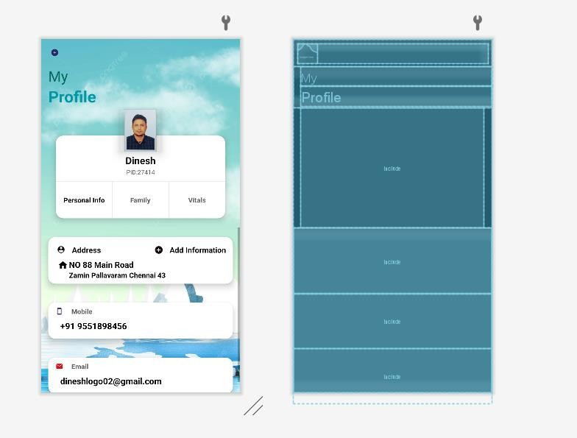

**Output Screen Shot:**

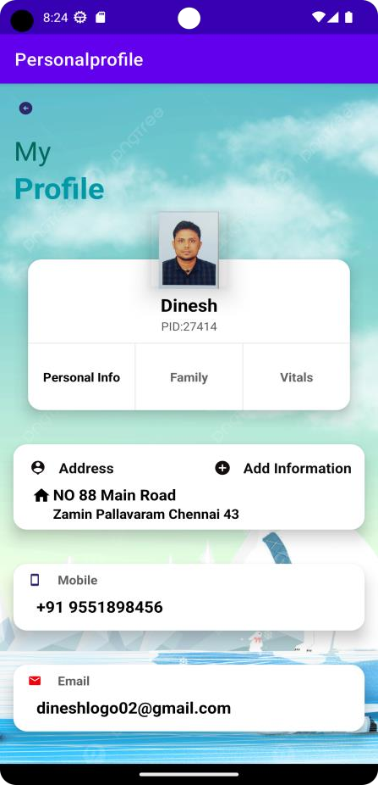

**Ex. No: 3**

**Date:**

**Using Radio Buttons**

# Aim:

To Develop an application that uses the radio button

**Algorithm:**

**Source Code:**

## Main Activity.xml

*?*xml version="1.0" encoding="utf-8"*?>*

<androidx.constraintlayout.widget.ConstraintLayout xmlns:android[="http://schemas.android.com/apk/res/android"](http://schemas.android.com/apk/res/android) xmlns:app[="http://schemas.android.com/apk/res](http://schemas.android.com/apk/res-auto)-[auto"](http://schemas.android.com/apk/res-auto) xmlns:tools[="http://schemas.android.com/tools"](http://schemas.android.com/tools) android:layout_width="match_parent" android:layout_height="match_parent" tools:context=".MainActivity" android:background="@drawable/beach">

<RadioGroup

android:id="@+id/radioGroup" android:layout_width="379dp" android:layout_height="381dp" app:layout_constraintBottom_toBottomOf="parent" app:layout_constraintTop_toTopOf="parent" app:layout_constraintVertical_bias="0.231" tools:ignore="MissingConstraints" tools:layout_editor_absoluteX="16dp">

<RadioButton

android:id="@+id/radioButton1" android:layout_width="match_parent" android:layout_height="wrap_content" android:onClick="onRadioButtonClicked" android:text="@string/java" android:textColor="#150F0D" android:textSize="20sp" android:textStyle="bold"

tools:ignore="TextContrastCheck,UsingOnClickInXml" />

<RadioButton

android:id="@+id/radioButton2" android:layout_width="match_parent" android:layout_height="wrap_content" android:onClick="onRadioButtonClicked" android:text="@string/python" android:textSize="20sp" android:textStyle="bold"

tools:ignore="UsingOnClickInXml,TextContrastCheck" />

<RadioButton

android:id="@+id/radioButton3" android:layout_width="match_parent" android:layout_height="wrap_content" android:onClick="onRadioButtonClicked" android:text="@string/c" android:textSize="20sp" android:textStyle="bold"

tools:ignore="UsingOnClickInXml,TextContrastCheck" />

<RadioButton

android:id="@+id/radioButton4" android:layout_width="match_parent" android:layout_height="wrap_content" android:onClick="onRadioButtonClicked" android:text="@string/net" android:textSize="20sp" android:textStyle="bold"

tools:ignore="UsingOnClickInXml,TextContrastCheck" />

<RadioButton

android:id="@+id/radioButton5" android:layout_width="match_parent" android:layout_height="wrap_content" android:onClick="onRadioButtonClicked" android:text="@string/c_programming" android:textSize="20sp" android:textStyle="bold" tools:ignore="UsingOnClickInXml" />

<RadioButton

android:id="@+id/radioButton6" android:layout_width="match_parent" android:layout_height="wrap_content" android:onClick="onRadioButtonClicked" android:text="@string/php" android:textSize="20sp" android:textStyle="bold"

tools:ignore="UsingOnClickInXml,TextContrastCheck" />

</**RadioGroup**>

<Button

android:id="@+id/button1" android:layout_width="wrap_content" android:layout_height="wrap_content" android:layout_marginBottom="176dp" android:background="#FEEA3B" android:backgroundTint="#FEEA3B" android:text="@string/get_course" app:layout_constraintBottom_toBottomOf="parent" app:layout_constraintEnd_toEndOf="parent" app:layout_constraintHorizontal_bias="0.5" app:layout_constraintStart_toStartOf="parent" />

<TextView

android:id="@+id/textView" android:layout_width="wrap_content" android:layout_height="wrap_content" android:layout_marginTop="25dp" android:text="@string/course_details" android:textColor="#5D4037"

android:textSize="24sp" android:textStyle="bold" app:layout_constraintEnd_toEndOf="parent" app:layout_constraintHorizontal_bias="0.5" app:layout_constraintStart_toStartOf="parent" app:layout_constraintTop_toTopOf="parent" />

<TextView

android:id="@+id/textResult" android:layout_width="301dp" android:layout_height="33dp" android:layout_marginBottom="108dp" android:background="#026576"

android:textAppearance="@style/TextAppearance.AppCompat.Large" android:textStyle="bold" app:layout_constraintBottom_toBottomOf="parent" tools:ignore="MissingConstraints" tools:layout_editor_absoluteX="0dp" />

</androidx.constraintlayout.widget.ConstraintLayout>

### Radio Button.java

**import** androidx.appcompat.app.AppCompatActivity;

**import** android.annotation.SuppressLint;

**import** android.os.Bundle; **import** android.view.View; **import** android.widget.Button;

**import** android.widget.RadioButton; **import** android.widget.TextView; **import** android.widget.Toast;

**public class** MainActivity **extends** AppCompatActivity { RadioButton **java**,**python**,**cpp**,**net**,**c**,**php**;

TextView **result**; Button **btn**;

@Override

**protected void** onCreate(Bundle savedInstanceState) { **super**.onCreate(savedInstanceState); setContentView(R.layout.***activity_main***);

**java**= findViewById(R.id.***radioButton1***); **python**= findViewById(R.id.***radioButton2***); **cpp**= findViewById(R.id.***radioButton3***); **net**= findViewById(R.id.***radioButton4***);

**c**= findViewById(R.id.***radioButton5***); **php**= findViewById(R.id.***radioButton6***); **result**= findViewById(R.id.***textResult***); **btn**= findViewById(R.id.***button1***);

**btn**.setOnClickListener(**new** View.OnClickListener() { @Override

**public void** onClick(View view) {

String selectedCourse = **"Selected Course:"**; **if** (**java**.isChecked()) {

selectedCourse += **"Java"**;

}

**if** (**python**.isChecked()) { selectedCourse += **"python"**;

}

**if** (**cpp**.isChecked()) { selectedCourse += **"C++"**;

}

**if** (**net**.isChecked()) { selectedCourse += **".net"**;

}

**if** (**c**.isChecked()) {

selectedCourse += **"C Programming"**;

}

**if** (**php**.isChecked()) { selectedCourse += **"PHP"**;

}

**result**.setText(selectedCourse);

}

});

}

@SuppressLint(**"NonConstantResourceId"**)

**public void** onRadioButtonClicked(View view) { **boolean** checked=((RadioButton)view).isChecked(); String str=**""**;

**switch** (view.getId()) {

**case** R.id.***radioButton1***:

**if** (checked) {

str = **"Java Selected"**;

}

break;

**case** R.id.***radioButton2***:

**if** (checked) {

str = **"Python Selected"**;

}

break;

**case** R.id.***radioButton3***:

**if** (checked) {

str = **"C++ Selected"**;

}

break;

**case** R.id.***radioButton4***:

**if** (checked) {

str = **".Net Selected"**;

}

break;

**case** R.id.***radioButton5***:

**if** (checked) {

str = **"C Programming Selected"**;

}

break;

**case** R.id.***radioButton6***:

**if** (checked) {

str = **"PHP Selected"**;

}

break;

}

Toast.*makeText*(getApplicationContext(),str,Toast.***LENGTH_SHORT***).show();

}

}

### Design Screen Shot:

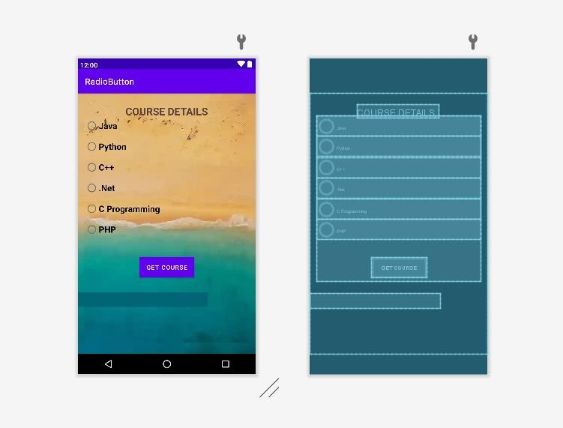

**Output Screen Shots:**

